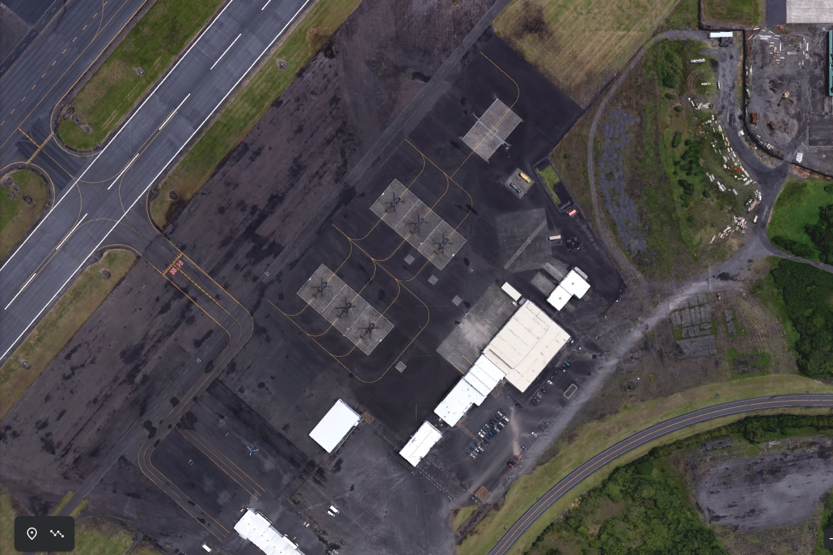
Bird Bath
Wash Rack

